AURA DATA Layer
Unified multi-source real estate intelligence for Portugal
Prepared for AURA (Adaptive Unified Real Estate Intelligence Engine)
Scope: market listings, official market data, macro-financial signals, socioeconomic context, ESG proxies, and regulatory risk
This document consolidates the final dataset strategy, architecture, limitations, and integration logic.

1. Overview
The DATA layer is the unified data backbone of AURA. Rather than depending on a single source, it combines complementary datasets so that valuation, demand, ESG, and compliance signals can be interpreted together.
This multi-source design keeps the system decision-oriented and explainable. Each dataset contributes a different lens on the Portuguese real estate market: what is being listed, what the official market says, how financing conditions affect demand, how neighborhoods behave, how buildings perform, and how regulation shapes investor risk.
Design principles
Why this structure matters:
- it reduces bias from single-source modeling,
- it makes valuation outputs easier to explain, and
- it supports dynamic seller decisions such as SELL_NOW, WAIT, REDUCE_PRICE, and HOLD.

2. Core Dataset Inventory
Component | Source / Dataset | Access | Granularity | Role in AURA
1.1 | Portugal Real Estate Listings 2024-2025 | CSV | Property | Primary market layer
1.2 | Portugal Housing Affordability and Market Factors | CSV / time-series | Regional / temporal | Market calibration and momentum
2 | Housing Price Index (INE 0009201) | API / CSV | National / NUTS II-III | Official calibration anchor
3 | BPstat Housing Credit & Interest Rates | API / CSV | National | Demand and liquidity engine
4 | PORDATA Portugal Database | CSV / Excel | Municipality / region | Neighborhood intelligence
5 | Portugal Buildings (OpenStreetMap Export) | GeoJSON / GIS | Building-level | ESG proxy engine
6 | RNAL - Alojamento Local Registry | API (JSON) | Property-level | Regulatory and demand pressure

3. Dataset Components and Roles

3.1 Category 1 - Property Listings (Market Layer)
The listings layer combines a current market snapshot with a longer-term calibration dataset.
- Portugal Real Estate Listings 2024-2025: property-level listings with price, area, rooms, location, property type, and partial energy labels.
- Portugal Housing Affordability and Market Factors: longitudinal regional time-series that tracks price trends, affordability, and market cycles from 2009 to 2025.
Together, these datasets capture seller behavior, listing inventory, trend dynamics, and affordability pressure. They are the market-facing foundation for AURA valuation.

3.2 Category 2 - Official Market Data (Ground Truth Layer)
The Housing Price Index (INE 0009201) acts as the official calibration anchor.
- It normalizes listing prices against the observed market.
- It helps distinguish real appreciation from inflationary noise.
- It ensures that model outputs remain aligned with official transaction trends.

3.3 Category 3 - Financial and Macro Data (Demand Layer)
BPstat adds the financial context required to model demand and liquidity.
- Mortgage interest rates and Euribor describe affordability pressure.
- Housing credit conditions provide a market-wide liquidity signal.
- The layer is useful for simulating rate shocks and demand sensitivity.

3.4 Category 4 - Socioeconomic Context (Neighborhood Intelligence)
PORDATA is used to relate property value to the characteristics of the surrounding municipality or region.
- Population and migration capture demand size and future pressure.
- Income and labor statistics proxy household purchasing power and stability.
- This layer strengthens explainability at neighborhood scale.

3.5 Category 5 - ESG / Energy Intelligence (Sustainability Layer)
The original EPC and EUBUCCO paths were not fully usable, so the ESG layer was reconstructed pragmatically with a proxy-based solution.
- SCE Energy Certification Database (ADENE): not accessible in a usable format during development.
- EUBUCCO: highly relevant, but impractical to use because the Portugal subset required very large archives and the public source was unstable.
- Portugal Buildings (OpenStreetMap Export): adopted final solution, providing building footprints that can be used for proxy-based EnergyScore, GreenPremium, and RenovationPotential features.
The adopted building-footprint dataset does not provide direct EPC labels, construction year, or thermal properties. It is therefore best interpreted as a spatial and structural proxy that can be combined with typology models such as TABULA for further energy estimation.

3.6 Category 6 - Regulatory and Risk Context (Compliance Layer)
RNAL (Alojamento Local Registry) is the official national registry of short-term rental properties.
- It includes property identification, accommodation type, capacity, and full address details.
- It is used to detect short-term rental density and tourism pressure.
- It is the key source for regulatory and compliance risk in Lisbon.
The API returned valid JSON data when queried directly, although the proxy interface showed instability. This limitation is documented rather than hidden.

4. Architecture Diagrams
The two diagrams below summarize how the layers connect and how the data flows into the final decision engine.

4.1 DATA Integration Pipeline
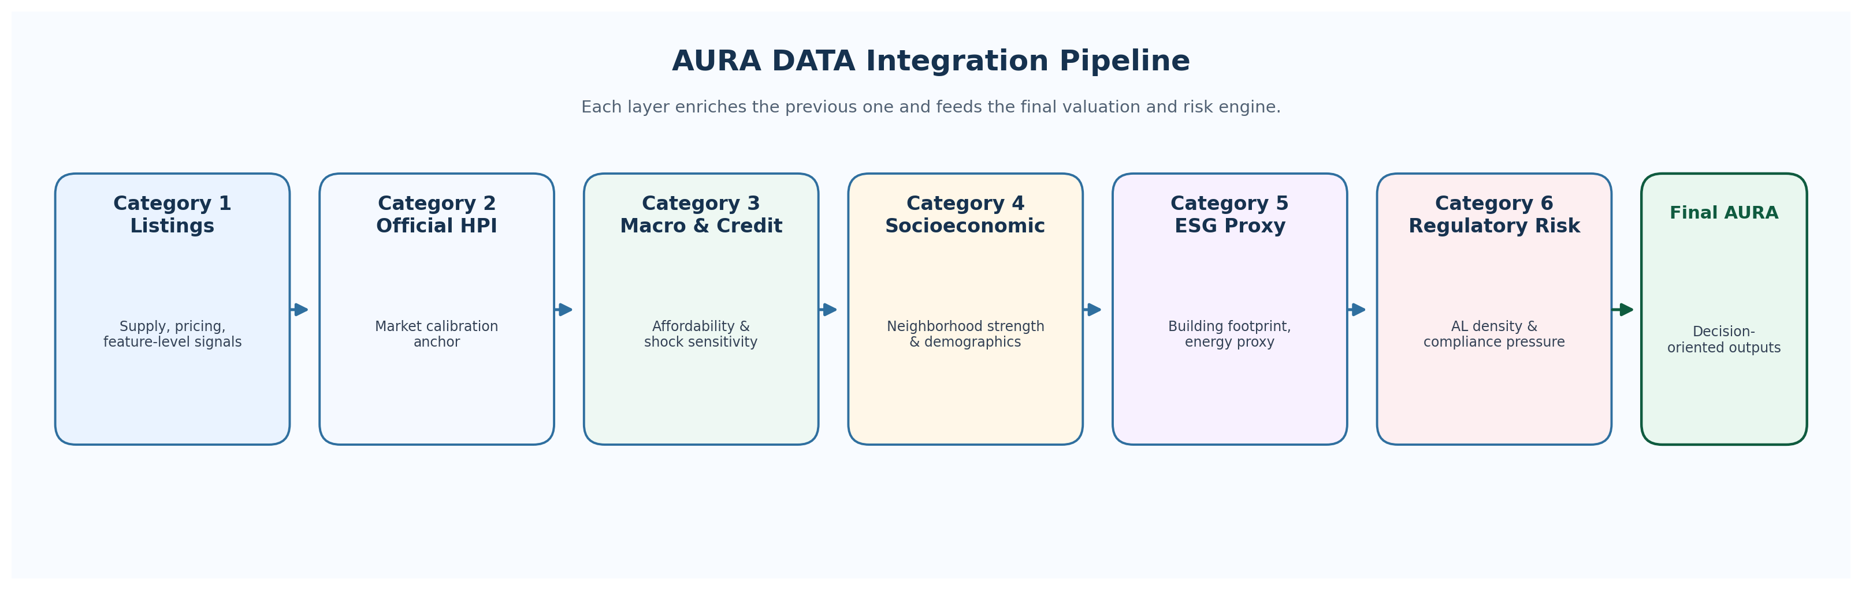
Figure 1. Sequential enrichment path from market listings to the final AURA intelligence layer.

4.2 AURA Architecture Overview
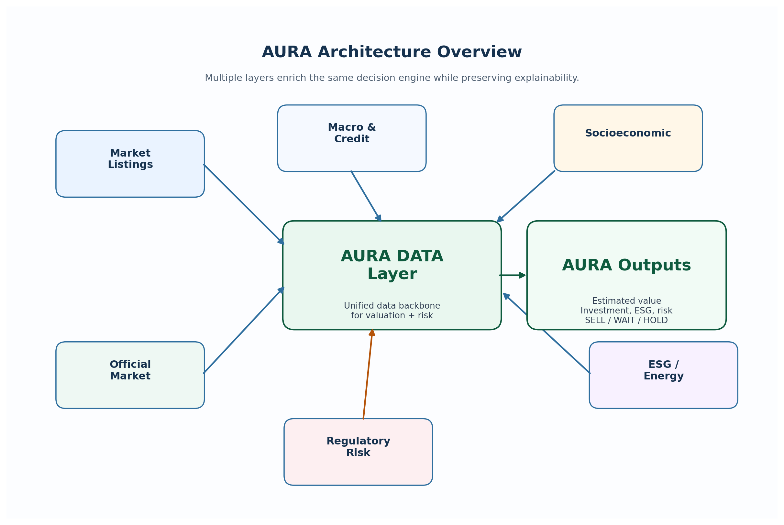
Figure 2. Layered architecture showing how the data backbone feeds the final outputs while preserving explainability.

5. Strategic Value for AURA
The DATA layer transforms AURA from a simple prediction model into a real estate intelligence system.
- Multi-source fusion reduces bias and improves robustness.
- Explainability is preserved because every score can be traced back to specific layers.
- The system becomes decision-oriented rather than purely predictive.

5.1 AURA Output Features
The integrated DATA layer produces both scoring outputs and decision outputs.
Output Type | Examples
Core scores | Estimated Property Value, Investment Score, Demand Score, Risk Score, ESG Score
Decision outputs | SELL_NOW, WAIT, REDUCE_PRICE, HOLD
Explanation layer | Market signals, macro conditions, demographics, ESG proxies, regulatory constraints

5.2 Limitations and Handling
Important limitations
Limitations documented in the report:
- SCE EPC data was not usable in the development phase.
- EUBUCCO access was impractical for the Portugal subset.
- The OSM footprint dataset provides a proxy, not an EPC label.
- The RNAL API was unstable through the proxy interface, even though direct JSON access worked.

6. Conclusion
The final DATA layer is production-oriented, explainable, and aligned with AURA's decision logic. It combines market, official, macro, socioeconomic, ESG, and regulatory signals into one coherent architecture.
The result is not a static pricing model, but an adaptive intelligence engine capable of supporting valuation, demand analysis, and risk-aware investment decisions in the Portuguese real estate market.

